**Family Fun Afternoon**

**Family Link Concert at St Mark’s Church, Biggin Hill on Saturday April 30th 4pm until 6pm**

**If you are looking for an afternoon of fun for all the family, young or old, and would like to support your local charity for children and young adults with physical complex and learning difficulties, then come join us**

**

**An interactive concert with opportunities for children to participate and use instruments to join in. Disney music from Moana, Lion King, and Jungle Book/Bear Necessities and more**

**Refreshments Tombola** **Raffle Prizes**

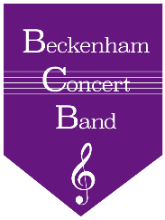

**No Entry Fee - Donations welcome to support Family Link Wheelchair accessible**