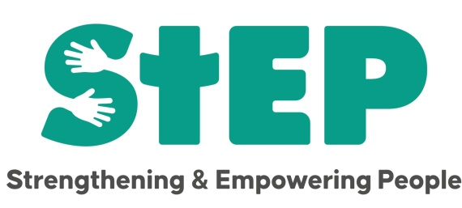

**Its Afternoon Tea time at StEP!**

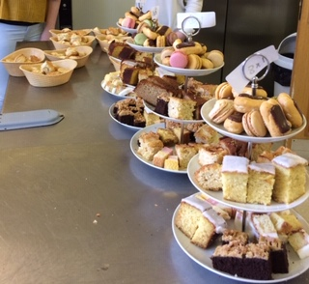

Our next event is in **April** to celebrate the coronation of King Charles.



Tickets, which will be £5.50 per person, will be available on a first come first serve basis with the date to be announced nearer the time.

So if you fancy a little bit of the *Ritz in Mottingham* be sure to come along enjoy the food, the company, the entertainment and let yourself be indulged!

You may want to try out some of our other projects too. Here’s a run-down of what we do!

Term time only:

Tuesday - 10.30 to 12

Play and Stay: Parent and toddler group.

Wednesday - 4.45 to 6.15pm

Mini Ed’s: Youth group for those in school years 4 and 5

Throughout the year

Thursday - 10.30am

Community Brunch: Full English with unlimited tea and coffee. The first Thursday of each month is a continental breakfast.

Friday - 12.30

Community Lunch: A 3 course meal, unlimited tea and coffee and a quiz for fun.

StEP also has its own confidential counselling service by appointment.

For more details on any of our projects please check out-

Facebook page - STEP or Website - https:// step-community.org.uk.

Alternatively email

Alev, administrator on alev.stedproject@gmail.com

or

Sue, Project Manager on [sue.stedproject@gmail.com](mailto:sue.stedproject@gmail.com)

Look forward to seeing you soon! 